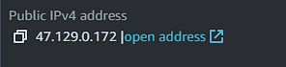Aws bastion host

Bastion host IPV4

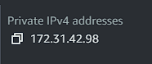Bastion Host private IP

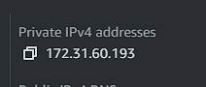Private server 1 private IP

Private server 2 private IP



1. ping private server 1 from bastion host.

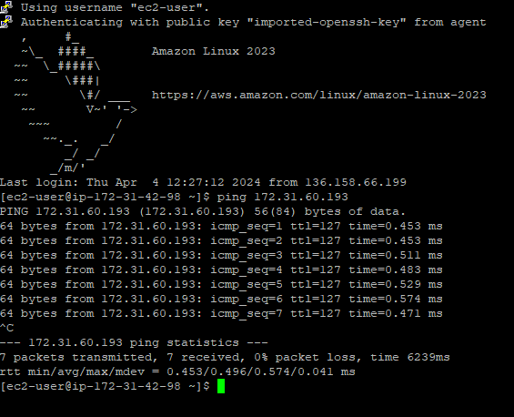The bastion host can ping the private server because their subnet and route table are connected in same VPC. Also the private servers and the bastion host are on the same security group.

1. Ping Private Server 2 from Private Server 1.

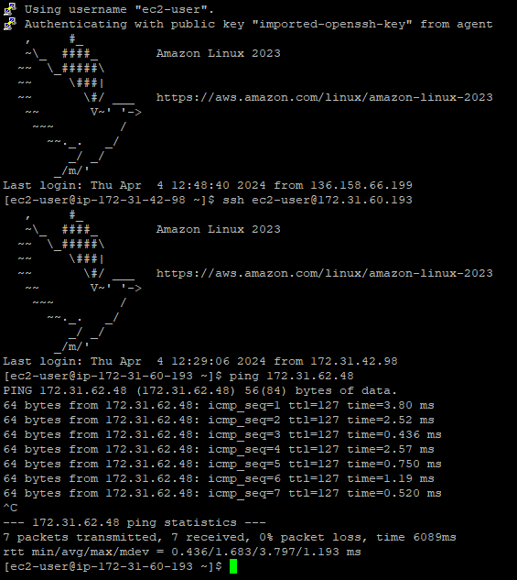Here we first open the bastion host then inside the bastion host we open other ssh that is the private serve 1, then we ping private server 2 from there.

1. ping bastion host from private server 2.

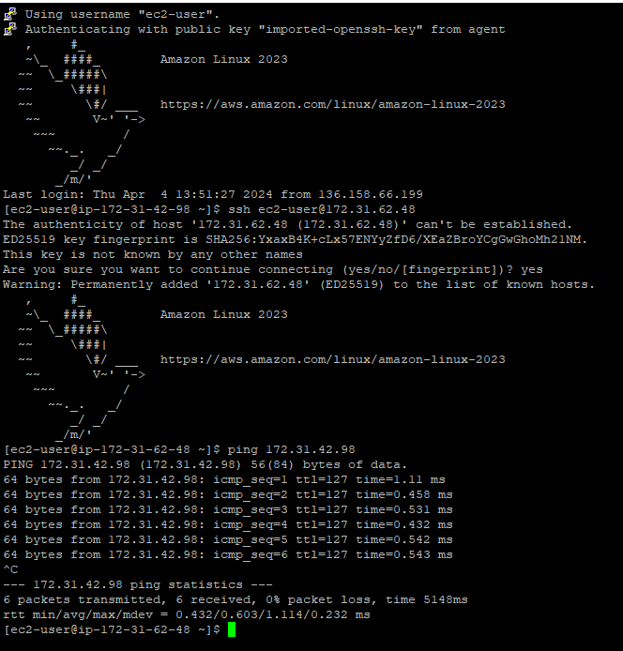In here we open the bastion host using ssh then inside we open private server 2. We those because we can access private serve 2 directly with our pc

1. Ping Bastion Host from Private Server 1.

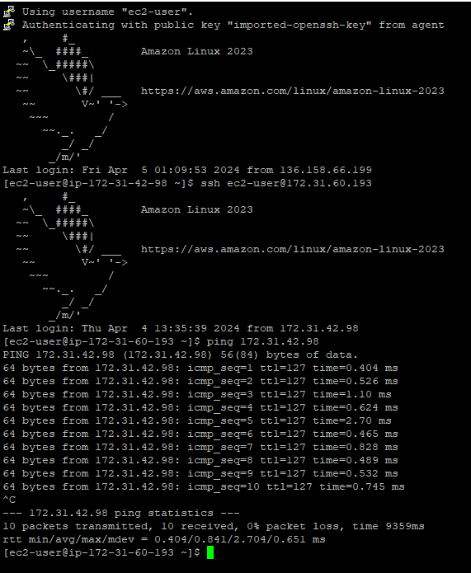Same goes in here we first open the bastion host in our pc and then inside bastion host we open private server 1 and then we ping the bastion host.